## **CGMM**

# Theory Assignment – 1

**Q. Explain flat panel display - Emissive display and Non-Emissive display.**

Flat-Panel Devices are the devices that have less volume, weight, and power consumption compared to Cathode Ray Tube (CRT). Due to the advantages of the Flat-Panel Display, use of CRT decreased. As Flat Panel Devices are light in weights that’s why they can be hang on walls and wear them on our wrist as a watch. Flat Panel Display (FPD) allow users to view data, graphics, text and images.

**Types of Flat Panel Display:-**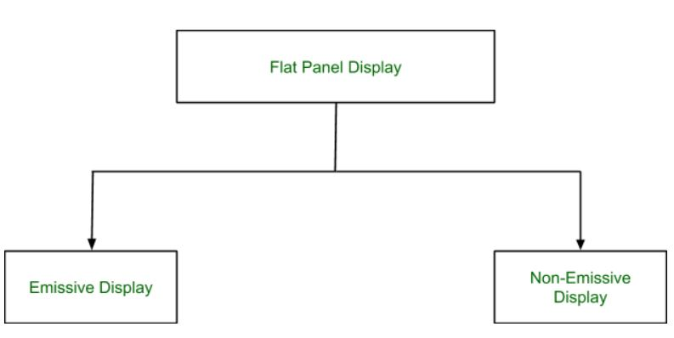

1. **Emissive Display:-**  
   The Emissive Display or Emitters are the devices that convert electrical energy into light energy.

**Examples:**

Plasma Panel :- A plasma display is a computer video display in which each pixel on the screen is illuminated by a tiny bit of plasma or charged gas, somewhat like a tiny neon light.

LED (Light Emitting Diode):- LED is a type of LCD that actually accompanies the advancement of technology. This replaces the fluorescent tube with backlight technology, which produces a clearer picture than the LCD.

Flat CRT:- CRT is a technology used in traditional computer monitors and televisions.

1. **Non-Emissive Display:-**Non-Emissive Display or Non-Emitters are the devices that use optical effects to convert sunlight or some other source into graphic patterns.

**Examples:**

LCD (Liquid Crystal Display) :- LCD stands for Liquid Crystal Display. It is a flat panel display technology, mainly used in TVs and computer monitors, nowadays it is used for mobile phones also.

**Advantages of Flat Panel Devices :-**

* Flat Panel Devices like LCD produces high quality digital images.
* Flat Panel monitor are stylish and have very space saving design.
* Flat Panel Devices consumes less power and give maximum image size in minimum space.
* Flat Panel Devices use its full color display capability.
* Full motion video can be viewed on Flat Panel Devices without artifacts or contrast loss.